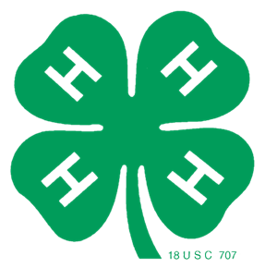


BUFFALO COUNTY 4-H LEADERS’ ASSOCIATION
Youth Officer-Led Meeting
Buffalo County Courthouse
January 18th, 6:00 p.m.

VOLUNTEER AWARDS

ICE BREAKER

AGENDA
6:10 PM - Call meeting to order/ 4-H Pledge
6:15 PM - Secretary’s Report
6:20 PM - Treasurer’s Report
6:25 PM – 4-H Program Updates – Extension Office
- 4-H Program Overview (Winter Challenge, Clover Connect, Website, etc.)
- STEM Toolkit Spotlight
- 4-H Educator Position
- Area Extension Director
6:35 PM - Old Business
- National Congress Travel Report – Marley Brommer
- 2025-26 4-H Leaders Association Committees Update
    - Food stand manager
- 4-H Festival of Arts Survey Results
- 2026 Program Priorities
    - Camps (4-H Camp, Cloverbud Days, etc.)
    - Project Learning (SPARKS Day)
    - Leadership (Officer training, Volunteer Education, etc.)
6:50 PM - New Business
- 2026 Countywide Service-Learning Project
- 2026 Fundraising
    - 4-H Cash Raffle
    - Other
- Summer Intern
7:00 PM - Any Other Business Properly Brought Before the Association
7:05 PM - Set Next Meeting Date
7:10 PM - Adjourn

Reminders:
Pepin/Buffalo Shooting Sports Practices – January 12 – March 31
Beef Weigh-ins – February 21, 2026
Building a Better Fair Gala – February 28, 2026
YQCA Dates Set – March 16 & 23, 2026

