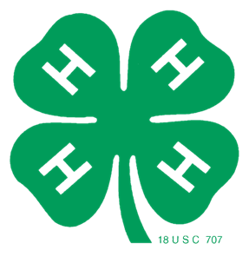


BUFFALO COUNTY 4-H LEADERS’ ASSOCIATION
Youth Officer-Led Meeting
Buffalo County Courthouse
March 15th, 6:00 p.m.

ICE BREAKER – Youth Officers

AGENDA
6:10 PM - Call meeting to order/ 4-H Pledge
6:15 PM - Secretary’s Report
6:20 PM - Treasurer’s Report
6:25 PM – 4-H Program Updates – Extension Office
- 4-H Program Overview/Upcoming Programs
- 4-H Newsletter
- STEM Toolkit Spotlight
- Kari Weiss, Area Extension Director Introduction
6:35 PM - Old Business
- 2026 Summer Intern/4-H Assistant Update
- National Congress Travel Report – Marley Brommer
- 2025-26 4-H Leaders Association Committees Reports
    - Food Stand
    - Fundraising – Calendar Raffle
- Online Zoom Opportunities
    - SPARKS Training - Laurie Bauer
    - Clover Connect
- Buffalo County Fair Gala Donation Update
6:50 PM - New Business
- 2026 Countywide Service Learning – Connections Across Generations
- Drivers Authorization Requirement
7:00 PM - Any Other Business Properly Brought Before the Association
7:05 PM - Set Next Meeting Date
7:10 PM - Adjourn

Reminders:
YQCA Dates Set – March 16 & 23, 2026 – Pre-registration required
Project Enrollment Deadline – April 1
Paws & Tails Dog Project Fun Day – April 18
Sheep/Goat Weigh-in – April 25
Animal Information Entered in 4-H Online – May 1

